2502465
DS LAB TASKS
TASK 1:
OUTPUT:

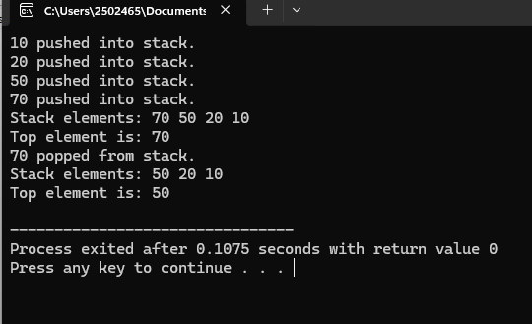

TASK 2:
OUTPUT:
